### ABESEC Ghaziabad

**Department of Computer Science & Engineering**

**Mini Project REPORT- KCS-354 (2019-20)**

|  |  |  |  |  |
| --- | --- | --- | --- | --- |
| **Project Title**  **RESTAURENT MANAGEMENT SYSTEM** | | | | |
| **Project Type**-Application | |  | | |
|  | **Name** | **Roll Number** | **Section** | **Signature** |
| **Group member (1)** | **Shivani goel** | **1803210140** | **A** |  |
| **Group member (2)** |  |  |  |  |
| **Group member (3)** |  |  |  |  |
| **Project Guide** |  | **Remarks:** | | |
| **Signature** |  |
| **Date of submission** |  |

**STUDENT’S DECLARATION**

I hereby declare that the work being presented in this report entitled “RESTAURANT MANAGEMENT SYSTEM” is an authentic record of my own work carried out under the supervision of “Mr.PRIYANSH AND Mr. ROHIT RASTOGI”.

The matter embodied in this report has not been submitted by me for the

award of any other degree.

**Dated: Signature of student:**

**Name:Shivani goel**

**Department: Cse,Btech**

This is to certify that the above statement made by the candidate is correct to the best of my knowledge.

### Signature of Supervisor

**CONTENTS OF REPORT**

### Problem Introduction

* + 1. Motivation
    2. Project Objective

1.1.3 Scope of the Project

### Related Previous Work

* 1. **Software and Hardware Requirements**
  2. **Proposed Method**
  3. **Deliverables**
  4. **Stakeholders**
  5. **Gantt Chart**
  6. **Reference**
  7. **PROBLEM INTRODUCTION**
     1. **MOTIVATION**

Primarily, the motivation for doing this project is the interest to develop something in an interesting area of research. Also, the teachers motivated me to do a project by our own so as to get more knowledge regarding the language we are working on.The results that we have achieved after doing the project has assurely improved our knowledge and motivated us to do more research on the project to make it more better and reliable.

## PROJECT OBJECTIVE:

 1-The system is designed to handle all the primary information and calculate the information about administration as well as customer.

2-This project is made more friendly as it is easy to handle in various activities such as record updating , maintenance and searching.

3-The searching of the record has been made quite simple as any of the detail can be obtain by simple keying the identification of the given record.

## Scope Of The Project:

1-This project will help the management to know about customers order details.

2-This will allow administration to know about its its employees .

3-This project will deduce the time and labour work.

4-This will help in generating financial statements fast and accurately.

5-This will help in accessing data whenever.

6-Help in providing efficient staff management.

# Software and Hardware Requirements

SERVER:

Processor : intel core i3

Speed : 1.7 GHz Memory Capacity : 4 GB

SOFWARE:

Operating System : Windows 10 Programming Language : C

Editor : Code blocks

# Proposed Methods

## Algorithm

* + - * First, make the main menu which has three options i.e administration ,customer then exit.
      * Then if enter 1 for administration , there will be six choices.
      * Choices are add the new record , search the record ,delete record ,view record ,view previous order placed.
      * This administration function will help to calculate all the records and the orders placed.
      * If enter 2 for customer ,there will be three choices .
      * Choices are vegetarian, non vegetarian .

If you will press enter 4 …EXIT.

## Flow Diagram

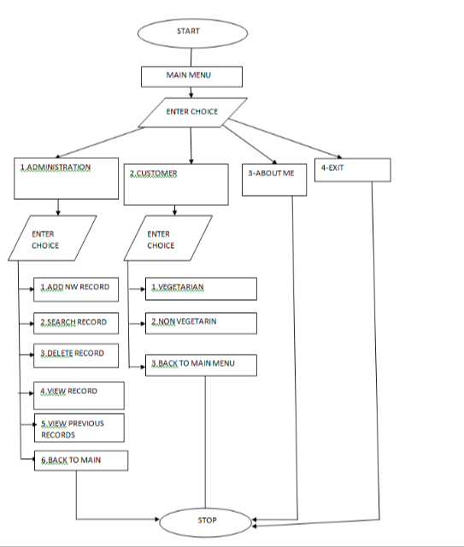

**Code**

Main function

administration();

}

void searchrecord(void)

{

system("cls");

int d;

printf(" *****************************Search Employees Record*********************************\n\n");

printf(" 1. Search By ID\n");

printf(" 2. Search By Name\n\n");

printf(" Enter Your Choice---> ");

fp=fopen("record1.txt","r");

rewind(fp);

switch(getch())

{

case '1':

{

system("cls");

printf(" **************Search Record By Id****************\n\n");

printf(" Enter The Employee ID : ");

scanf(" %d",&d);

printf("\n\n");

printf("Searching........");

while(fread(&e,sizeof(e),1,fp)==1)

{

if(e.id==d)

{

printf("\n\n");

printf("...........................The Record is available............................\n\n");

printf(" ID : %d\n\n",e.id);

printf(" Name : %s\n\n",e.name);

printf(" Date OF Birth :%d/%d/%d\n\n",e.dd,e.mm,e.yyyy);

printf(" Year Of Joining :%d\n\n",e.YOJ);

printf(" Department :%s\n\n",e.department);

printf(" Place :%s\n\n",e.place);

findrecord='t';

}

}

if(findrecord!='t')

{

printf("\aNo Record Found\a");

}

printf("Try Another Search ? (y/n)");

if(getch()=='y')

searchrecord();

else

administration();

break;

}

case '2':

{

char s[15];

system("cls");

printf(" **********************Search Employees By Name***************************\n\n");

printf(" Enter Employee Name : ");

scanf(" %s",s);

int d=0;

while(fread(&e,sizeof(e),1,fp)==1)

{

if(strcmp(e.name,(s))==0)

{

printf(" .........................The Record is available...........................\n\n\n");

printf(“ ID : %d\n\n",e.id);

printf(" Name : %s\n\n",e.name);

printf(" Date OF Birth :%d/%d/%d\n\n",e.dd,e.mm,e.yyyy);

printf(" Year Of Joining :%d\n\n",e.YOJ);

printf(" Department :%s\n\n",e.department);

printf(" Place :%s\n\n",e.place);

d++;

}

}

if(d==0)

{

printf("\aNo Record Found\a");

}

printf("Try Another Search ? (Y/N)");

if(getch()=='y')

searchrecord();

else

administration();

break;

}

default :

getch();

searchrecord();

}

fclose(fp);

}

void viewrecord(void)

{

system("cls");

printf(" ********************** Employee Details**********************\n\n");

printf(" DEPARTMENT ID EMPLOYEE NAME D.O.B Y.O.J PLACE\n\n");

fp=fopen("record1.txt","r");

while(fread(&e,sizeof(e),1,fp)==1)

{

printf(" %s",e.department);

printf(" %d",e.id);

printf(" %s",e.name);

printf(" %d/%d/%d",e.dd,e.mm,e.yyyy);

printf(" %d",e.YOJ);

printf(" %s",e.place);

printf("\n\n");

}

fclose(fp);

returnfunc();

}

void returnfunc(void)

{

{

printf(" Press ENTER to return to main menu");

}

e:

if(getch()==13)

administration();

else

goto e;

}

int checkid(int c)

{

rewind(fp);

while(fread(&e,sizeof(e),1,fp)==1)

if(e.id==c)

return 0;

return 1;

}

int getdata()

{

printf(" Employee ID :\t");

scanf("%d",&t);

if(checkid(t)==0)

{

printf("\n\n");

printf("\a The Employee Record Already Exists !!!\a");

getch();

mainmenu();

return 0;

}

e.id=t;

printf(" Employee Name : ");

scanf("%s",e.name);

printf(" Date Of Birth (dd/mm/yyyy) :");

scanf("%d/%d/%d",&e.dd,&e.mm,&e.yyyy);

printf(" Year OF Joining :");

scanf("%d",&e.YOJ);

printf(" Place :");

scanf("%s",e.place);

printf(" Department :");

scanf("%s",e.department);

return 1;

}

void customer(void)

{

system("cls");

printf(" ************************************************\n WELCOME\n ************************************************\n\n");

printf(" YOU ARE--->\n\n 1. Vegetarian\n\n 2. Non Vegetarian\n\n OR\n\n 3. Back To Main Menu\n\n Enter Your Choice -->");

int k;

scanf("%d",&k);

int wait;

for(wait=0;wait<=50000;wait++)

{

printf("\rIn progress : %d",wait/500);

}

if(k==1)

{

system("cls");

vegetarian();

}

else if(k==2)

{

system("cls");

nonvegetarian();

}

else if(k==3)

{

system("cls");

mainmenu();

}

else

{

printf("Wrong Input !Please Re-enter The Correct Option......\n\n");

customer();

}

}

void vegetarian(void)

{

int choice;

int again;

int quantity;

double price=0;

printf(" ****************************************\n VEGETARIAN MENU\n ****************************************\n\n");

printf(" 1. Burger 40/-\n 2. Noodles 60/-\n 3. Sandwich 45/-\n 4. Beverages 35/-\n 5. Veg. Thaali 150/-\n -->Dal\n -->Paneer\n -->Chapati\n -->Rice\n -->Papad\n 6. Back To Main Menu\n\n Enter Your Choice--> ");

char v;

FILE *vmenu;

vmenu=fopen("vegmenu.txt","rt");

while((v=getc(vmenu))!=EOF)

{

printf("%c",v);

}

fclose(vmenu);

}

# Deliverables

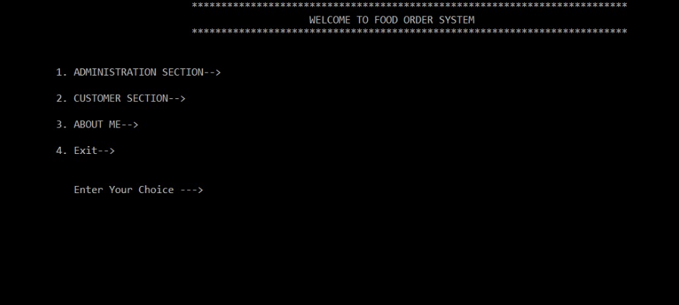

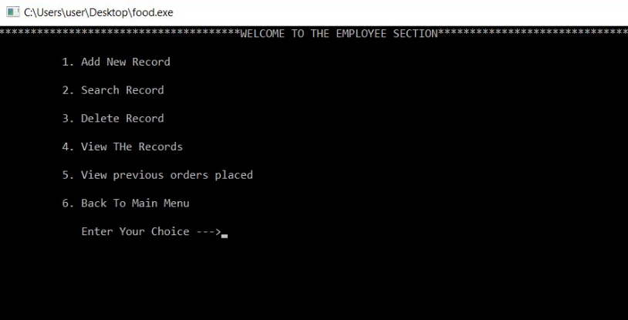

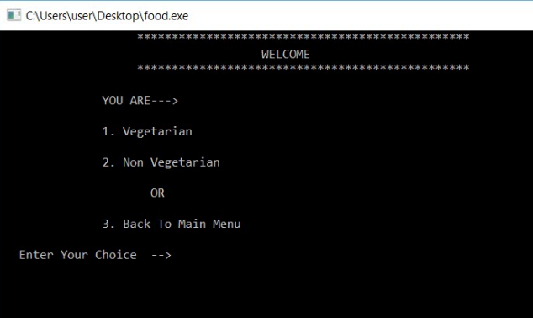

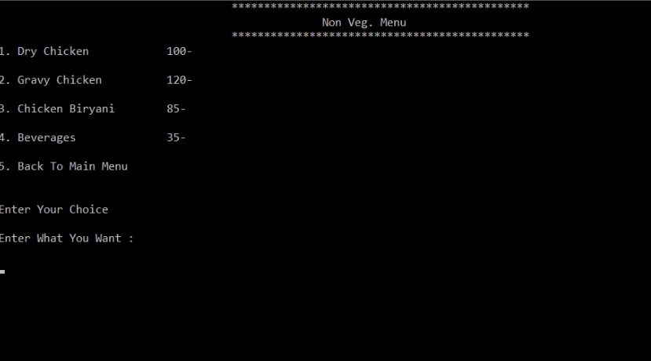

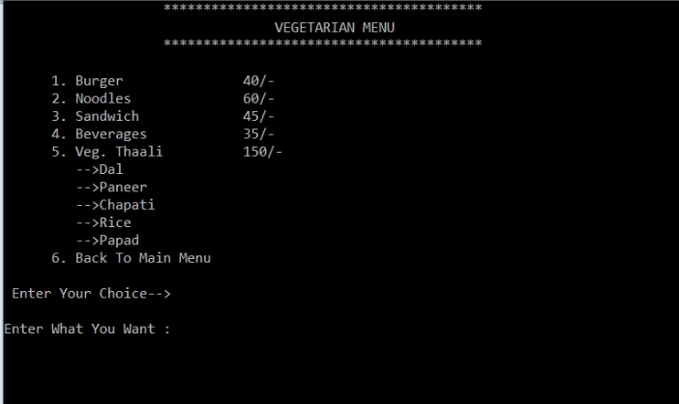

* 1. **Stakeholders**
* Administration
* customer
* food
* vegetarian
* Non-vegetarian

# Gantt Chart

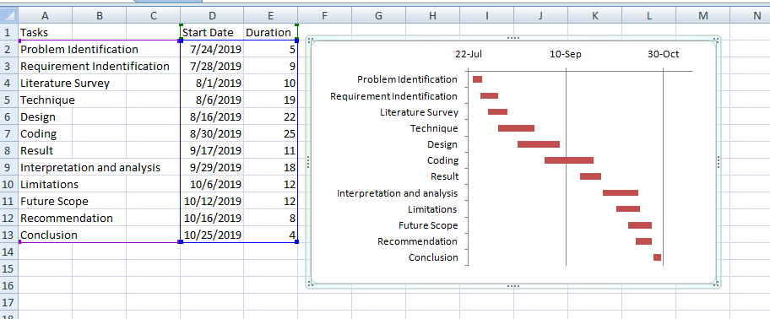

* 1. **References**

https://www.w3schools.com/

https://www.geeksforgeeks.orghtt